**A Brief History of Visual Basic**

Visual Basic is a third-generation event-driven programming language first released by Microsoft in 1991. The final version of the classic Visual Basic was Visual Basic 6. Visual Basic 6 is a user-friendly programming language designed for beginners. It enables anyone to develop GUI Windows applications easily. Many developers still favour VB6 over its successor VB.NET.

In 2002, Microsoft released Visual Basic.NET (VB.NET) to replace Visual Basic 6.VB.NET is a fully object-oriented programming language implemented in the .NET Framework. It was created to cater for the development of the web as well as mobile applications. Subsequently, Microsoft has released many versions of VB.NET. They are Visual Basic 2005, Visual Basic 2008, Visual Basic 2010, Visual Basic 2012, Visual Basic 2013, Visual Basic 2015, Visual Basic 2017 and Visual Basic 2019.

Microsoft has released Visual Studio 2019 in early 2019. VS 2019 allows us to code in different programming languages and different platforms, Visual Basic 2019 is one of them. The other Programming languages are C# C++, F#, JavaScript, Java and Python. Visual Basic 2019 is the latest version of the VB.NET programming language released by Microsoft.

**Installation of Visual Studio 2019**

We can download the free version of Visual Studio 2019 from the following link:

https://visualstudio.microsoft.com/vs/

Clicking the link brings up the Visual Studio 2019 download page, as shown in Figure 1.1

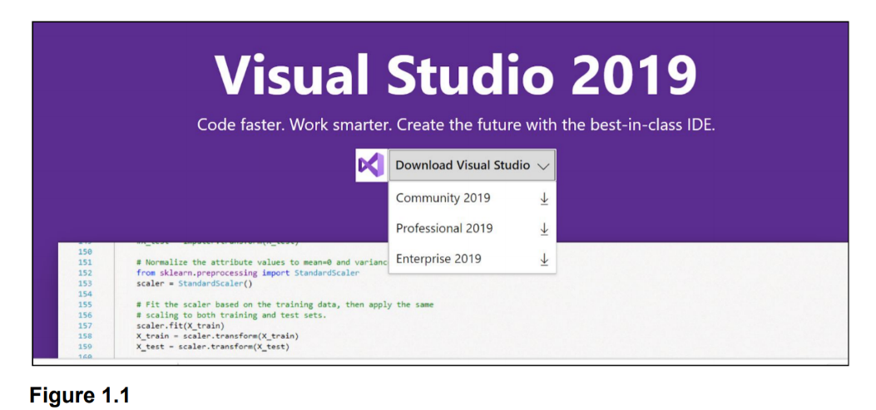

You can choose the free Visual Studio Community 2019 or the Full-featured Professional 2019 and End-to-End solution Enterprise 2019 to download. The free version provides full-featured IDE for students, open source community and individuals.

Select community and download the installer file. The downloaded installer file will appear on your Windows 10 taskbar. Click it to install Visual Studio 2019. Clicking the Visual Studio 2019 Installer will start downloading, unpacking and installing the files necessary for the installation of Visual Studio 2019, as shown in Figure 1.2

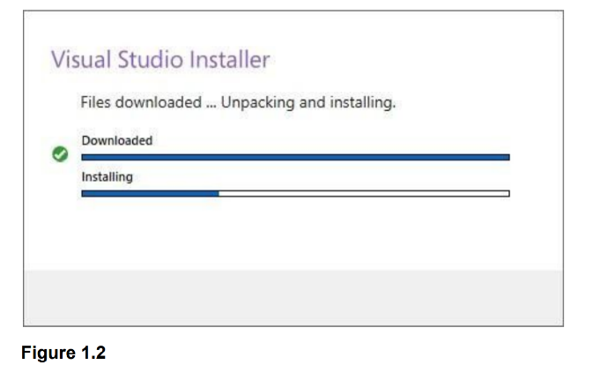

We will see several status screens that show the progress of the installation. After the installer has finished installing, it is time to pick the feature set that we wish to install, as shown in Figure 1.3. Since we are focusing on developing Visual Basic 2019 desktop app, we will select the .NET desktop development component. After making our selections, click install.

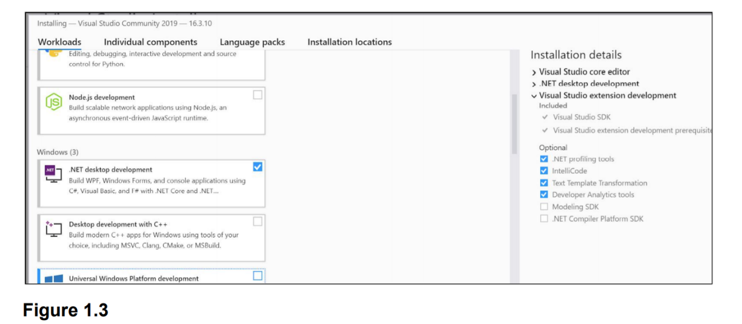

Upon completion of the installation, we are now ready to launch Visual Studio 2019 and start programming in Visual Basic 2019.

**Creating a Visual Basic 2019 Project**

To create a Visual Basic 2019 project, launch Microsoft Visual Studio 2019.

Launching VS 2019 will bring up the Visual Studio 2019 Start Page, as shown in Figure 1.4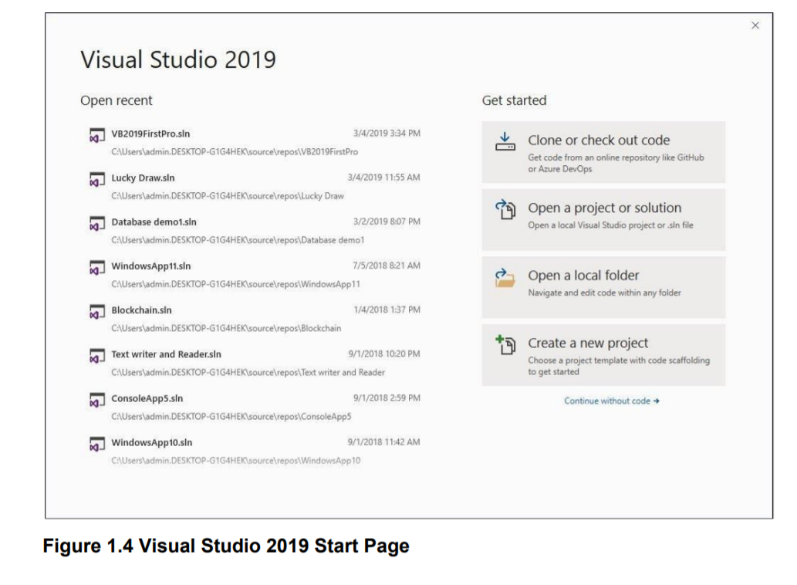

The Visual Studio 2019 start page comprises two sections, the Open Recent section and the Get Started section. In the start page, we can select a recent project file or choose any option in the Get Started section. We can choose to clone a project from GitHub or Azure DevOps, open a project or solution, open a local folder, create a new project, or continue without code.

Let us create a new project by clicking on the Create a new project option. We will see the Create a new project template page, as shown in Figure 1.5. In the Create a new project page, select Visual Basic language.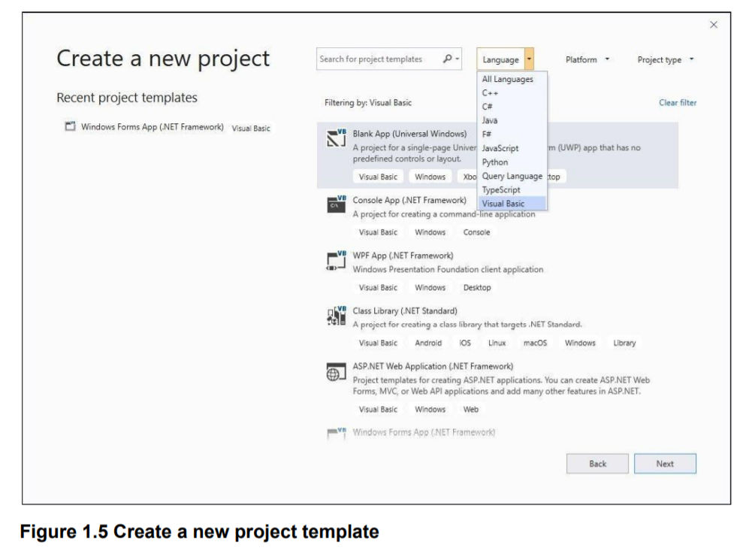

Next, select the Windows Forms App (.Net Framework) template as we want to develop a Windows desktop project, as shown in Figure 1.5

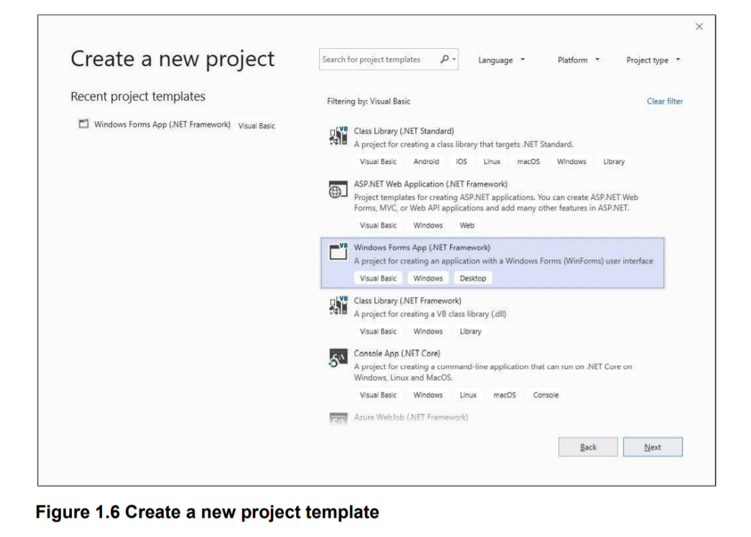

Upon clicking the selected project template, the project configuration page appears, as shown in Figure 1.7. We can configure our project by typing the project name and select a few other options.

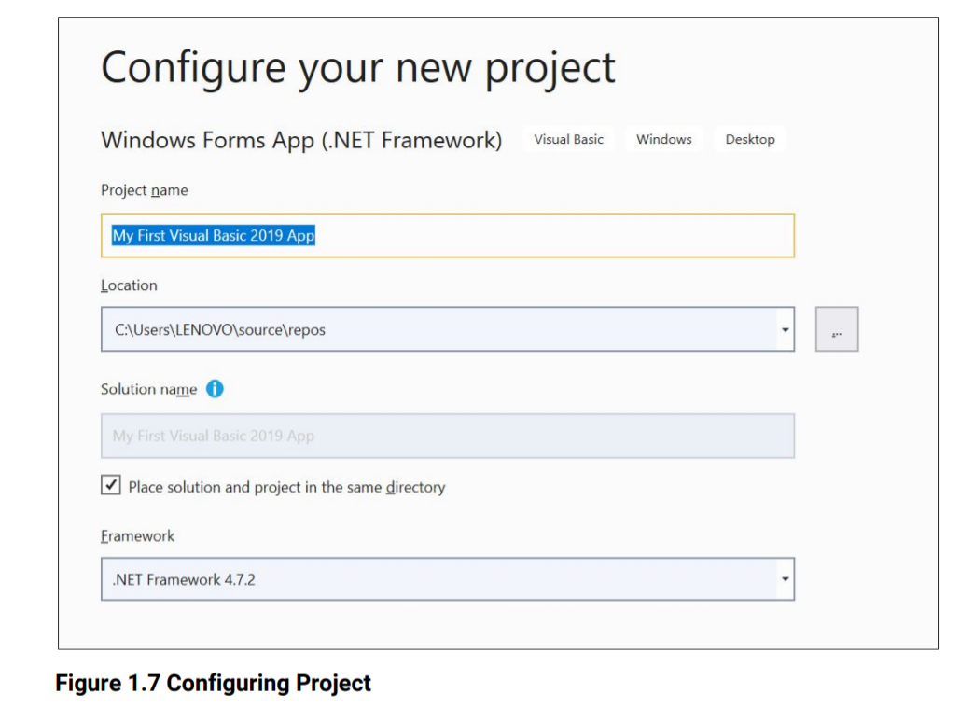

At the bottom of this dialog box, we can change the default project name WindowsApplication1 to some other name you like, for example, My First Visual Basic 2019 App. After renaming the project, click OK to continue. The Visual Basic 2019 IDE Windows will appear, as shown in Figure 1.8.

Visual Basic 2019 IDE comprises a few windows, the Form window, the Solution Explorer window, and the Properties window. It also consists of a toolbox which contains many useful controls that allows the programmer to develop his or her Visual Basic 2019 programs.

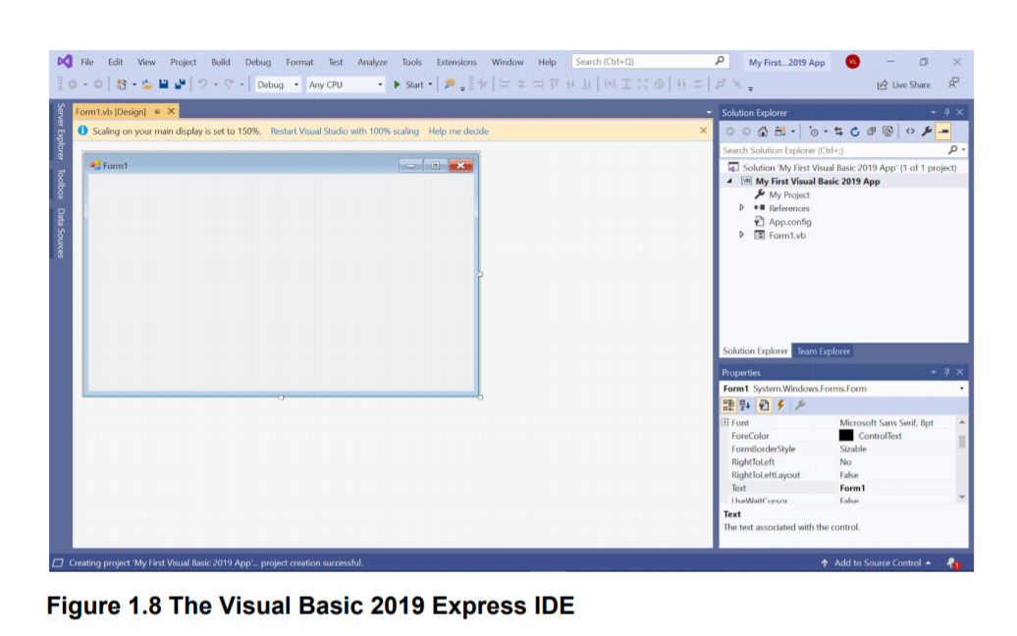

The Toolbox is not shown until we click on the Toolbox tab. When we click on the Toolbox tab or use the shortcut keys Ctrl+Alt+x, the common controls Toolbox will appear, as shown in Figure 1.9.

We can drag and move our toolbox around and dock it to the right, left, top or bottom of the IDE.

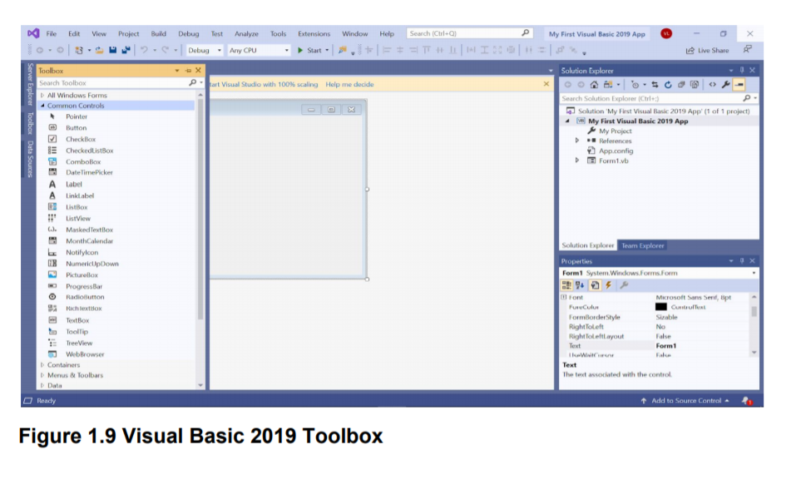

Next, we shall proceed to show us how to create our first VB2019 application.

First, change the text of the form to ‘My First VB 2019 App’ in the properties window.

It will appear as the title of the application. Next, insert a button and change its text to OK.

The design interface is shown in Figure 1.10

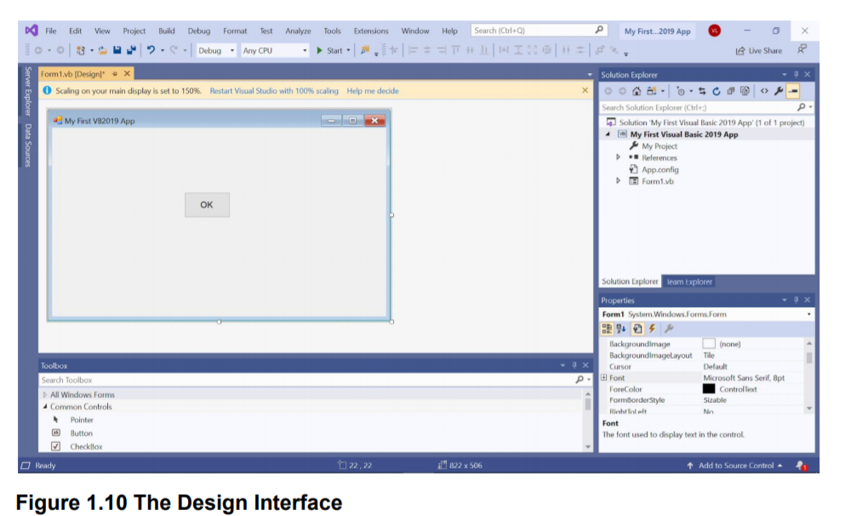

Now click on the OK button to bring up the code window and enter the following statement between Private Sub and End Sub procedure, as shown in Figure 1.11.

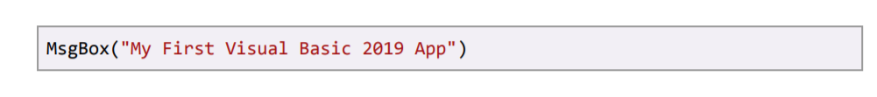

Clicking the Start button on the toolbar or press F5 to run the application will launch the runtime interface, as shown in Figure 1.12. Executing the application by clicking on the OK button will bring up a dialog box that displays the “My First Visual Basic 2019 App" message, as shown in Figure 1.13. The function MsgBox is a built-in function of Visual Basic 2019 which can display the text enclosed within the brackets.

